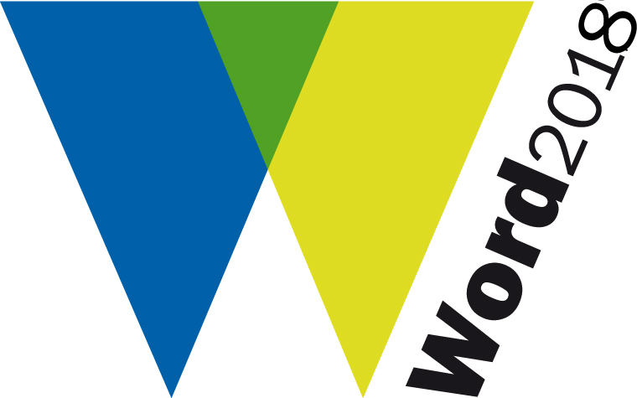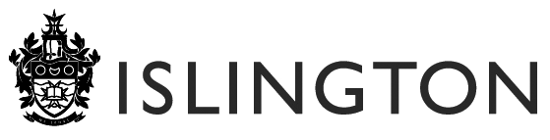

WORD2018 Co-promotion Proposal Form

Please provide the following information for each of the activities or events you would like to be considered for promotion as part of the Word2018 Festival (1-30 June 2018).

Please complete a separate form for each different activity or event you would like us to promote.

- CONTACT DETAILS

Artist/Organisation:
Primary Contact:
Position within organisation:
Address:
Tel: | Fax:
Email: | Website:

- SUMMARY PROJECT DETAILS

Name of proposed activity:
Dates for proposed activity:
Venue and booking details for activity:

Artists and Arts organisations involved in your activity:

Non-arts partners involved in your activity (if applicable):

- WORD2017 THEMES AND TARGET AUDIENCES

Please tick which of the three themes you will address with your proposed project:
Older adults with dementia (65 years and over) and their families
Young people with mental health difficulties (specifically projects that work to improve the wellbeing of young people aged 13 – 25 years) and their families
Children (especially early years – 1- 5 years) and their families.

Or, if your project targets a different participant group or audience, please tell us who the target beneficiaries of your project are here:

- CO-PROMOTION PROPOSAL

When completing this section please make sure you refer to the criteria in the Word2017 Festival Commission, Co-production and Co-promotion Proposal Guidelines

4.1 Project Outline (max 500 words)
Please provide an outline summary of your proposed activity or event:

  - Copy about your event/activity for publicity - (max 100 words) :
(If your submission is successful, this will be used in the festival brochure and/or website)

DECLARATION

By signing this form, you agree to the following:

We will use this proposal form and the other information you give us, including any personal information, for the following purposes.

- To decide whether to promote the activity described as part of the Islington Word2017 festival
- To hold in our database and use for statistical purposes.

I confirm that the organisation named on this application has given me the authority to sign this application on its behalf.

I confirm that the activity in the application falls within the powers of the organisation's constitution or memorandum and articles of association (the legal document setting out the rules governing the organisation).

I confirm that, as far as I know, the information in this application is true and correct.

Sign…………………………………………………. Date………………………………

Please email your completed application form to:

Suzanne Lee
Artistic Director (All Change)
Word Festival Creative Producer

T: 020 7689 4646
E: info@allchangearts.org

CLOSING DATE FOR COMPLETED SUBMISSIONS: 6pm Monday 5 March 2018

(Please note: If your proposal is successful, you will be sent a festival Marketing Form, which must be completed by Friday 24 March 2018)

